**TUGAS PRAKTIKUM**

**PENGEMBANGAN APLIKASI WEB**

**MODUL 7**

**“Framework Laravel”**



**Disusun Oleh:**

Nama : Ari Andi Mustofa

NIM : 200411100133

Kelas : PAW-4B

**Dosen Pengampu:**

Nama : Ach. Khozaimi,S.Kom,M.Kom.

NIP : 198609262014041001

**Asisten Praktikum:**

Nama : Alief Fadhilah Athallariq

NIM : 180411100028

**PRODI TEKNIK INFORMATIKA**

**JURUSAN TEKNIK INFORMATIKA  
FAKULTAS TEKNIK**

**UNIVERSITAS TRUNOJOYO MADURA**

**2022**

**Tugas Praktikum :**

1. Buatlah projek laravel dimana fungsi dari Web App tersebut antara lain :
2. Menambah Mahasiswa
3. Melihat semua Mahasiswa
4. Melihat mahasiswa berdasarkan NIM
5. Mengupdate data Mahasiswa
6. Menambah Nilai Mahasiswa (1 page berbeda dari update mahasiswa, karena khusus update untuk kolom nilai saja)
7. Menghapus Mahasiswa
8. Attribute :

* nim, nama, umur, alamat, nilai

1. Gunakan Blade Templating Engine :

* Framework CSS seperti Bootstrap/TailwindCSS/etc diperbolehkan

Jawab :

1. Membuat controller dan model
2. Controller

<?php

namespace App\Http\Controllers;

use App\Models*Mahasiswa*;

use Illuminate\Http*Request*;

*class* mahasiswaController extends *Controller*

{

    public *function* index(){

        $mahasiswa = *Mahasiswa*::all();

        return view('mahasiswa.index',compact(['mahasiswa']));

    }

    public *function* create(){

        return view('mahasiswa.create');

    }

    public *function* search(*Request* $request){

        $mahasiswa=*Mahasiswa*::Where('nim',$request->search)->get();

        return view('mahasiswa.index',compact(['mahasiswa']));

    }

    public *function* save(*Request* $request){

*Mahasiswa*::create($request->except(['_token','submit']));

        return redirect('/mahasiswa');

    }

    public *function* edit($id){

        $mahasiswa= *Mahasiswa*::find($id);

        return view('mahasiswa.edit',compact(['mahasiswa']));

        return redirect('/mahasiswa');

    }

    public *function* update($id,*Request* $request){

        $mahasiswa= *Mahasiswa*::find($id);

        $mahasiswa->update($request->except(['_token','submit']));

        return redirect('/mahasiswa');

    }

    public *function* editnilai($id){

        $mahasiswa= *Mahasiswa*::find($id);

        return view('mahasiswa.editnilai',compact(['mahasiswa']));

        return redirect('/mahasiswa');

    }

    public *function* hapus($id){

        $mahasiswa=*Mahasiswa*::find($id);

        $mahasiswa->delete();

        return redirect('/mahasiswa');

    }

}

1. Model

<?php

namespace App\Models;

use Illuminate\Database\Eloquent\Factories*HasFactory*;

use Illuminate\Database\Eloquent*Model*;

*class* Mahasiswa extends *Model*

{

    use *HasFactory*;

    protected $table = 'mahasiswa';

    protected $guarded=[];

}

1. Migration

<?php

use Illuminate\Database\Migrations*Migration*;

use Illuminate\Database\Schema*Blueprint*;

use Illuminate\Support\Facades*Schema*;

*class* CreateMahasiswa extends *Migration*

{

    /**

     * Run the migrations.

     *

     * @return void

     */

    public *function* up()

    {

*Schema*::create('mahasiswa', *function* (*Blueprint* $table) {

            $table->id();

            $table->string('nim');

            $table->string('nama');

            $table->string('umur');

            $table->string('alamat');

            $table->string('nilai');

            $table->timestamps();

        });

    }

    /**

     * Reverse the migrations.

     *

     * @return void

     */

    public *function* down()

    {

*Schema*::dropIfExists('mahasiswa');

    }

}

1. Menambah mahasiswa
2. Code *resources/view/layout/master.blade.php*

<!DOCTYPE html>

<html lang="en">

<head>

    <meta charset="UTF-8">

    <meta name="viewport" content="width=device-width, initial-scale=1.0">

    <meta http-equiv="X-UA-Compatible" content="ie=edge">

    <link href="https://cdn.jsdelivr.net/npm/bootstrap@5.2.0-beta1/dist/css/bootstrap.min.css" rel="stylesheet" integrity="sha384-0evHe/X+R7YkIZDRvuzKMRqM+OrBnVFBL6DOitfPri4tjfHxaWutUpFmBp4vmVor" crossorigin="anonymous">

    <title>@yield('title')</title>

</head>

<body style="background-color: #FFEE63;">

    @yield('content')

</body>

</html>

1. Code Form menambah mahasiswa

@extends('layout.master')

@section('title',"Tambah Mahasiswa")

@section('content')

<div class="container" style="width: 30%;background-color: aquamarine;border-radius:5%;margin-top:50px;">

    <center><h1 style="margin-top:30px;">Tambah Mahasiswa</h1></center>

    <form action="/mahasiswa/save" method="POST" >

        @csrf

        <div class="input-group mb-3">

            NIM<input type="text" name="nim" class="input-group mb-3" placeholder="NIM">

        </div>

        <div class="input-group mb-3">

            Nama<input type="text" name="nama" class="input-group mb-3" placeholder="Nama">

        </div>

        <div class="input-group mb-3" >

            Umur<input type="text" name="umur" class="input-group mb-3" placeholder="Umur">

        </div>

        <div class="input-group mb-3">

            Alamat<input type="text" name="alamat" class="input-group mb-3" placeholder="Alamat">

        </div>

        <div class="input-group mb-3">

            Nilai<input type="text" name="nilai" class="input-group mb-3" placeholder="Nilai">

        </div>

        <center><input class="btn btn-primary" style="margin-bottom: 20px;" type="submit" name="submit" value="Tambah"></center>

    </form>

</div>

@endsection

1. Hasil

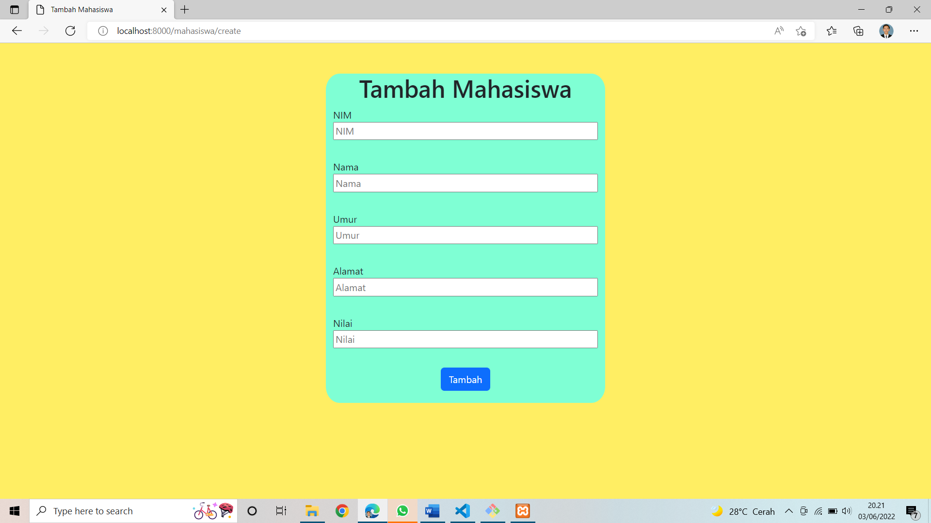

1. Melihat semua mahasiswa dan Melihat mahasiswa berdasarkan NIM
2. Code

@extends('layout.master')

@section('title',"Data Mahasiswa")

@section('content')

<div class="container">

    <center><h1>Daftar Mahasiswa</h1></center>

    <center><h1>"Pengembangan Aplikasi Web-4B"</h1></center>

    <form action="/mahasiswa/search" method="post" style="margin-top: 30px;">

        @csrf

        <div class="container mt-3" >

            <div class="row">

                <div class="col col-11">

                    <input type="search" name="search" style="width:1275px;height:40px;border-radius:10px;background-color:aqua">

                    <div class="col col-1">

                        <button class="btn btn-info" type="submit" style="margin-top: 10px;">Cari</button>

                    </div>

                </div>

            </div>

        </div>

        <center><a class="btn btn-primary" href="/mahasiswa/create">Tambah Mahasiswa</a></center>

    </form>

    <table class="table table-success table-striped" style="margin-top: 30px;">

        <tr>

            <th>No.</th>

            <th>NIM</th>

            <th>Nama</th>

            <th>Umur</th>

            <th>Alamat</th>

            <th style="text-align: center">Nilai</th>

            <th>Action</th>

        </tr>

        @foreach ($mahasiswa as $m)

        <tr>

            <td>{{ $m->id }}</td>

            <td>{{ $m->nim }}</td>

            <td>{{ $m->nama }}</td>

            <td>{{ $m->umur }}</td>

            <td>{{ $m->alamat }}</td>

            <td style="text-align: center">{{ $m->nilai }} <br><a class="btn btn-warning" style="width: 70px;margin-bottom:10px;" href="/mahasiswa/{{ $m['id'] }}/editnilai">Edit</a></td>

            <td><a class="btn btn-warning" style="width: 70px;margin-bottom:10px;" href="/mahasiswa/{{ $m['id'] }}/edit">Edit</a>

            <form action="/mahasiswa/{{ $m['id'] }}" method="POST">

                @csrf

                @method('delete')

                <input class="btn btn-danger" type="submit" value="Delete">

            </form>

            </td>

        </tr>

        @endforeach

    </table>

</div>

@endsection

1. Hasil lihat semua mahasiswa

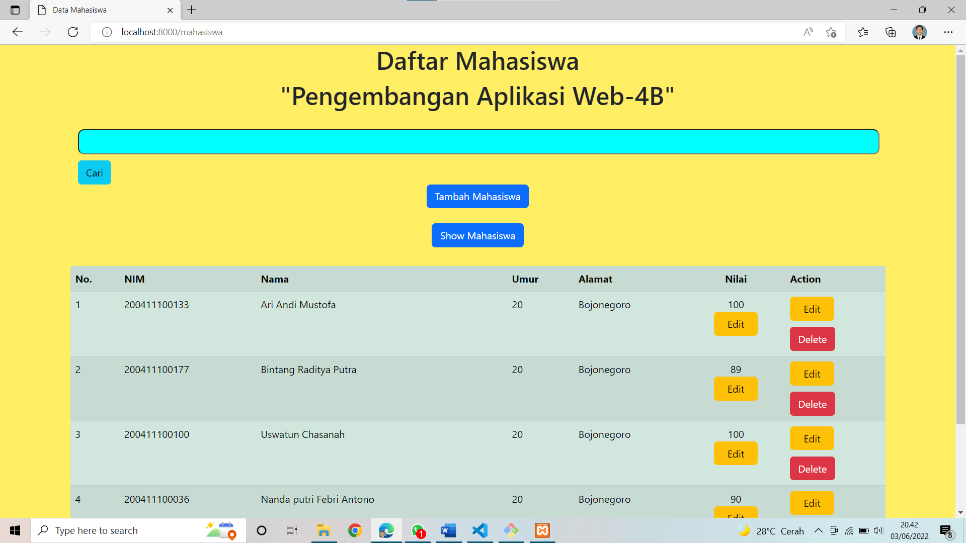

1. Hasil lihat mahasiswa berdasarkan NIM

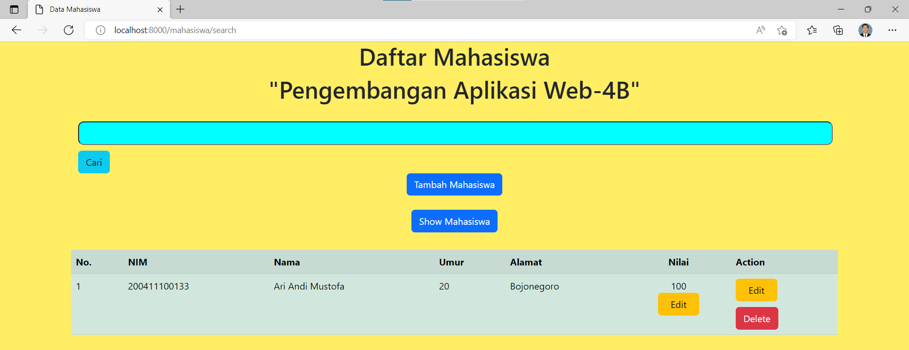

1. Mengupdate data Mahasiswa
2. Code

@extends('layout.master')

@section('title',"Edit Mahasiswa")

@section('content')

    <div class="container" style="width: 30%;background-color: aquamarine;border-radius:5%;margin-top:50px;">

        <center><h1 style="margin-top:30px;">Edit Mahasiswa</h1></center>

        <form action="/mahasiswa/{{ $mahasiswa->id }}" method="POST" >

            @method('put')

            @csrf

            <div class="input-group mb-3">

                NIM<input type="text" name="nim" class="input-group mb-3" placeholder="NIM" value="{{ $mahasiswa->nim }}">

            </div>

            <div class="input-group mb-3">

                Nama<input type="text" name="nama" class="input-group mb-3" placeholder="Nama" value="{{ $mahasiswa->nama }}">

            </div>

            <div class="input-group mb-3" >

                Umur<input type="text" name="umur" class="input-group mb-3" placeholder="Umur" value="{{ $mahasiswa->umur }}">

            </div>

            <div class="input-group mb-3">

                Alamat<input type="text" name="alamat" class="input-group mb-3" placeholder="Alamat" value="{{ $mahasiswa->alamat }}">

            </div>

            <center><input class="btn btn-primary" style="margin-bottom: 20px;" type="submit" name="submit" value="save"></center>

        </form>

    </div>

@endsection

1. Sebelum di update



1. Setelah di update

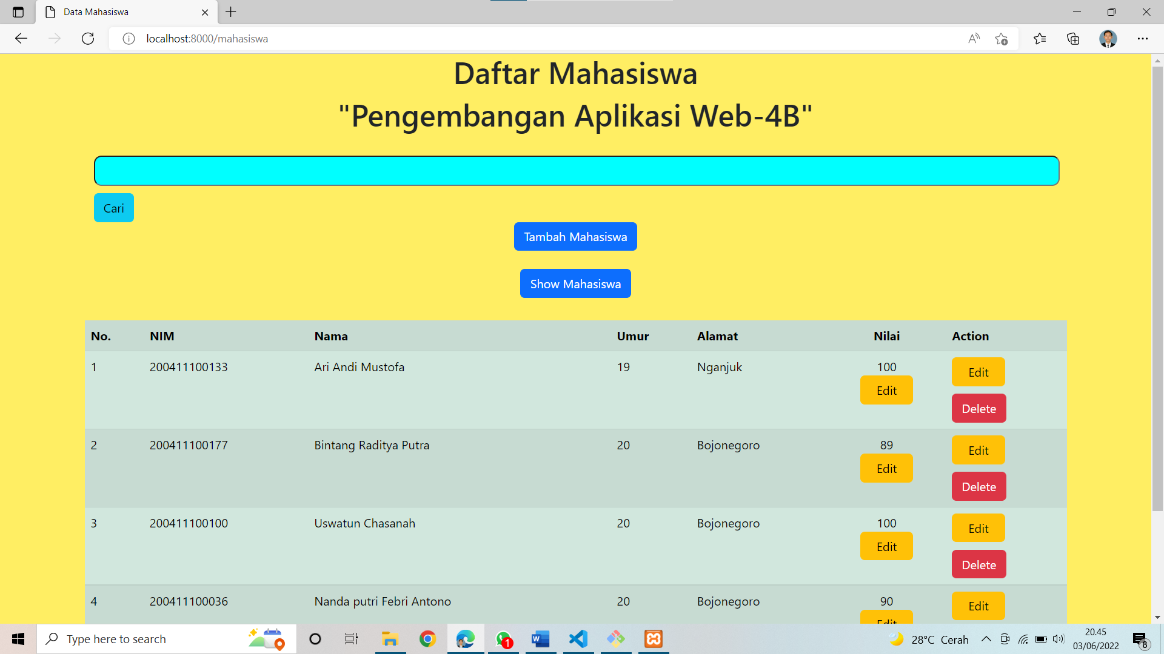

1. Menambah Nilai Mahasiswa
2. Code

@extends('layout.master')

@section('title',"Edit Nilai Mahasiswa")

@section('content')

    <div class="container" style="width: 30%;background-color: aquamarine;border-radius:5%;margin-top:50px;">

        <center><h1 style="margin-top:30px;">Edit Nilai Mahasiswa</h1></center>

        <form action="/mahasiswa/{{ $mahasiswa->id }}" method="POST" >

            @method('put')

            @csrf

            <div class="input-group mb-3">

                Nilai<input type="text" name="nilai" class="input-group mb-3" placeholder="Nilai" value="{{ $mahasiswa->nilai }}">

            </div>

            <center><input class="btn btn-primary" style="margin-bottom: 20px;" type="submit" name="submit" value="save"></center>

        </form>

    </div>

@endsection

1. Sebelum diupdate nilai



1. Setelah diupdate nilai

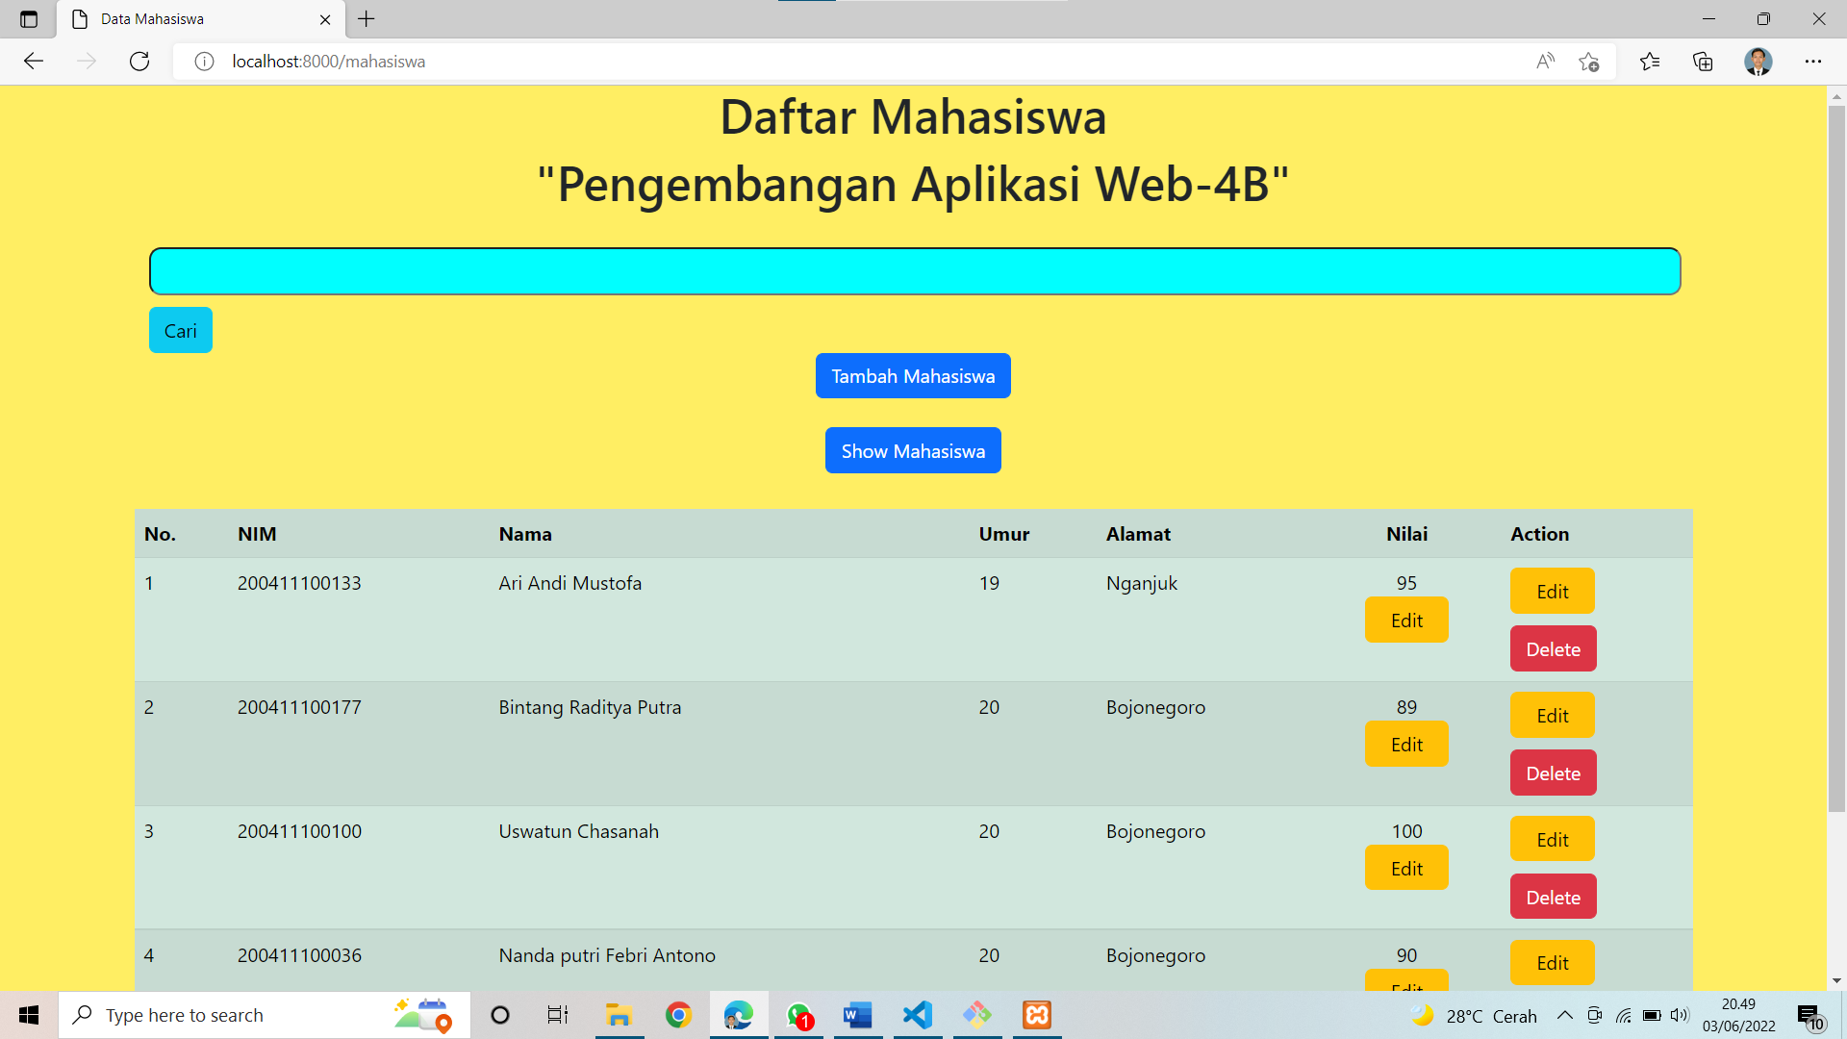

1. Menghapus mahasiswa
2. Code

<form action="/mahasiswa/{{ $m['id'] }}" method="POST">

                @csrf

                @method('delete')

                <input class="btn btn-danger" type="submit" value="Delete">

            </form>

1. Sebelum dihapus

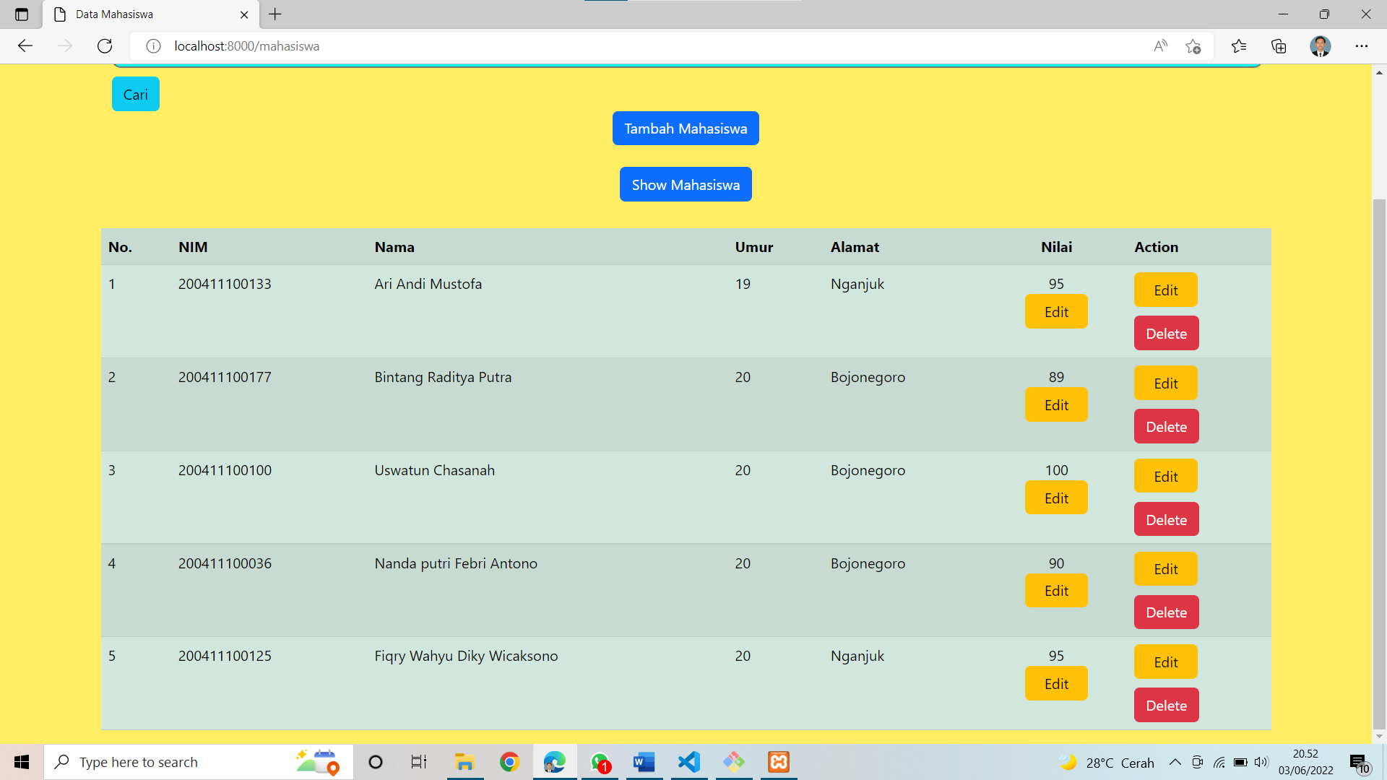

1. Setelah dihapus

